So in K-medoids how to determine best K.

Sometimes we are very sure about number of clusters we can get and so we can use it.

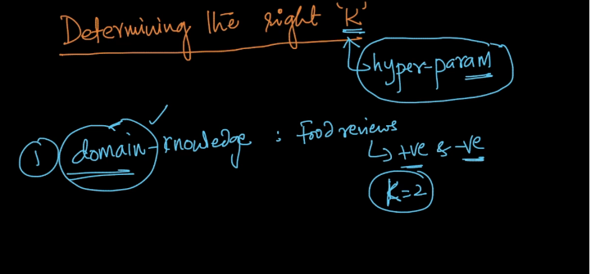

But in rest of the case we can use elbow method as shown below.

By plotting graph between loss function and different values of k.

